# GARGE MANAGEMENT SYSTEM

College Name:Shiri kumaran college of arts and science

College code:Bru5d

TEAM ID:

TEAM MEMBERS:

Team LeaderName:S.RUBA

Email:rubha355@gmail.com

Team Member1:S.KEERTHANA

Email:keerthanas9025@gmail.com

Team Member2:A.DEEPAK

Email:deepakdeepak91238@gmail.com

Team Members3:S.I.MOHAMAD IYYAS

Email:ootyooty68@gmail.com

# 1.INTRODUCTION

1.1 Project Overview

A Garge Management system helps efficiently manage vehicle service,repairs,and maintenance.It tracks customer details,vehicle information,and work order in one place.It improves workflow,reduces errors, and enhances customer satisfaction.



Created object:Customer details,vechicle management,billing and invoicing.

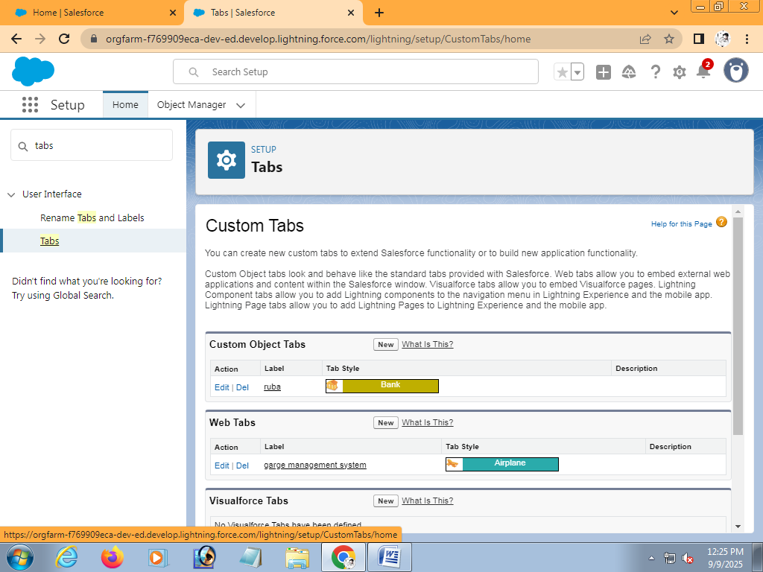

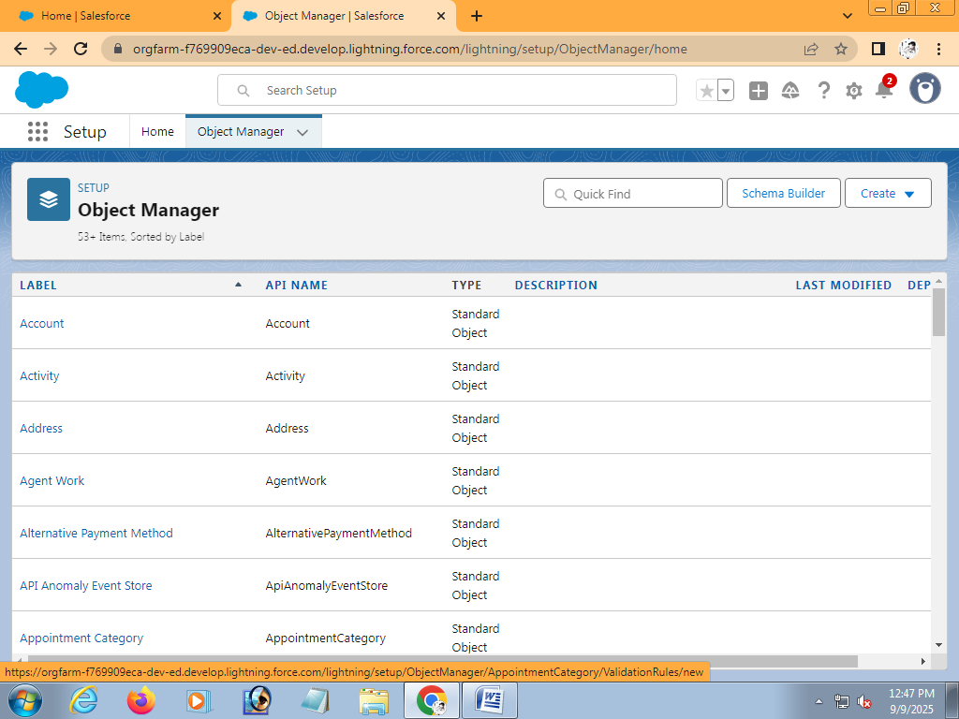

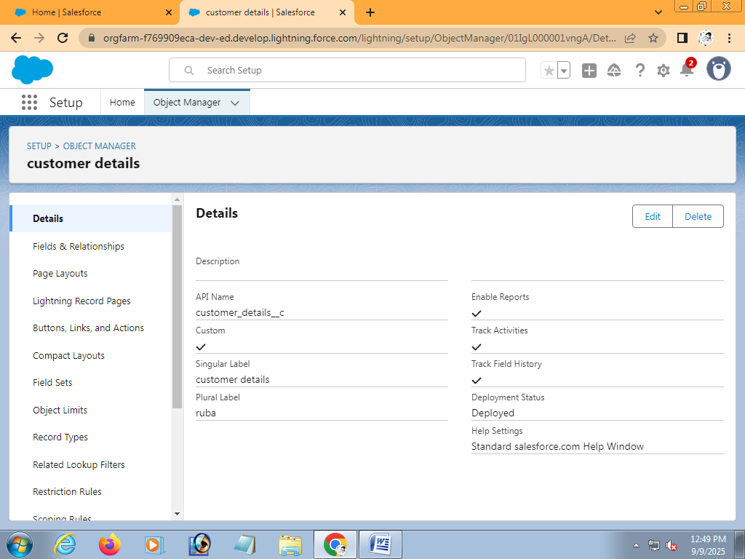

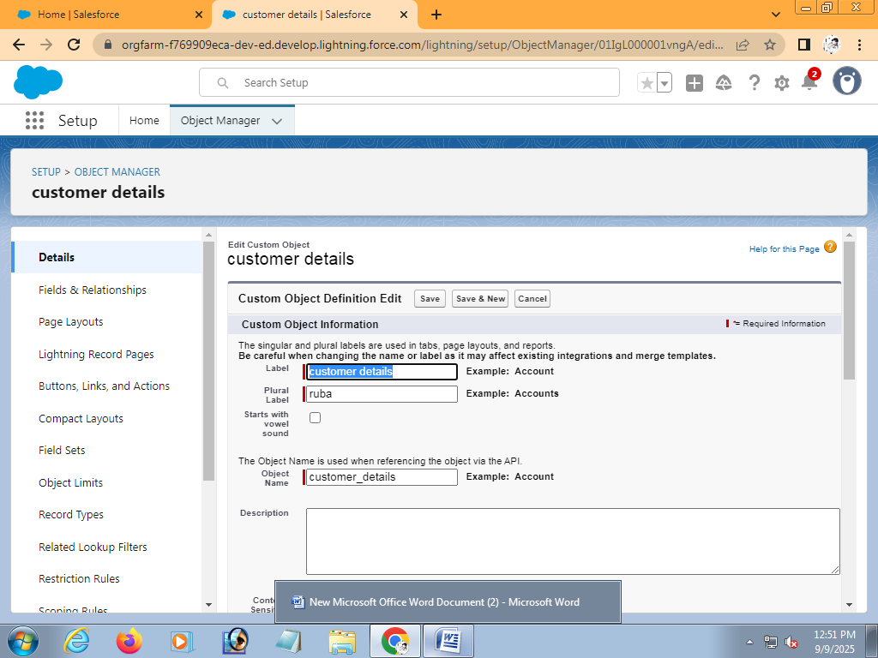

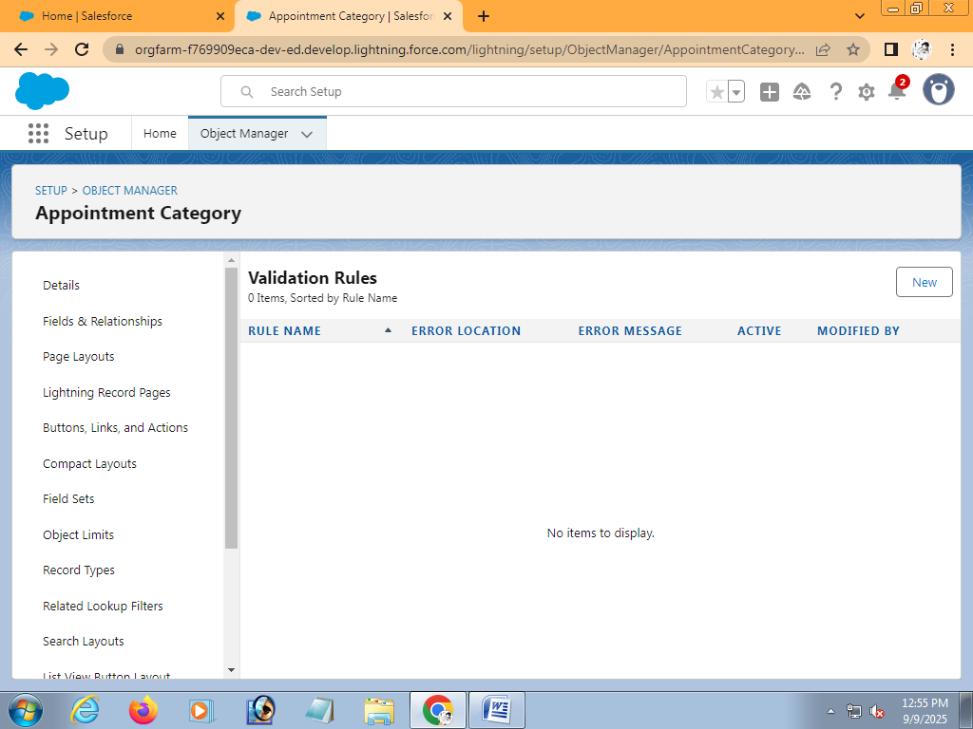

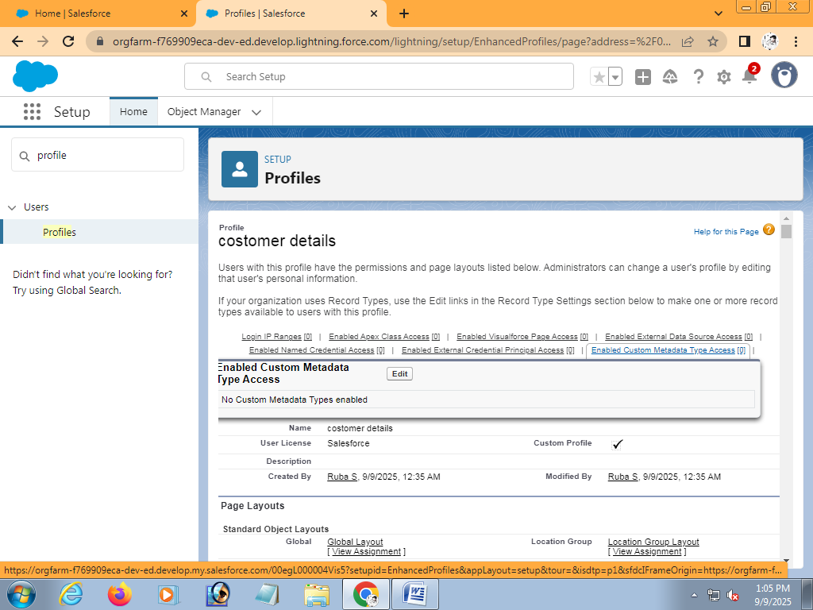

For users,agarge management system makes it easy to book services,track repairs,and get bill online.

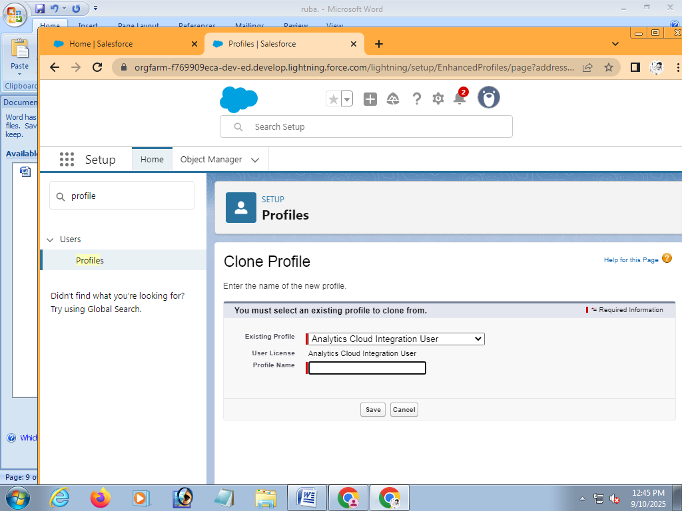

While still on the profile page,then click edit.

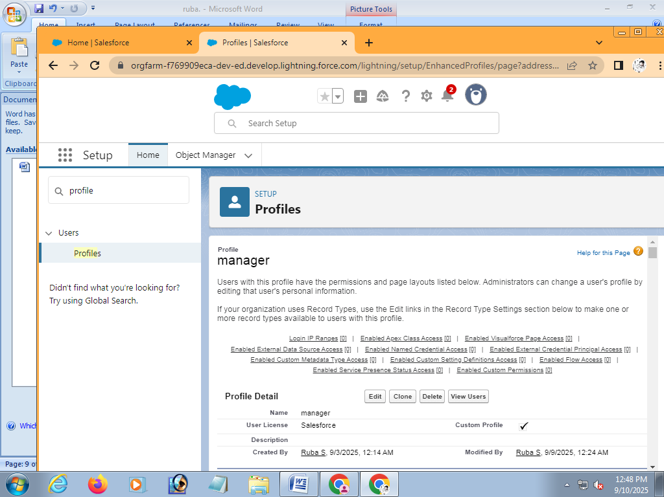

Give lable as “manager” and Role name gets auto populated.Then click on save.

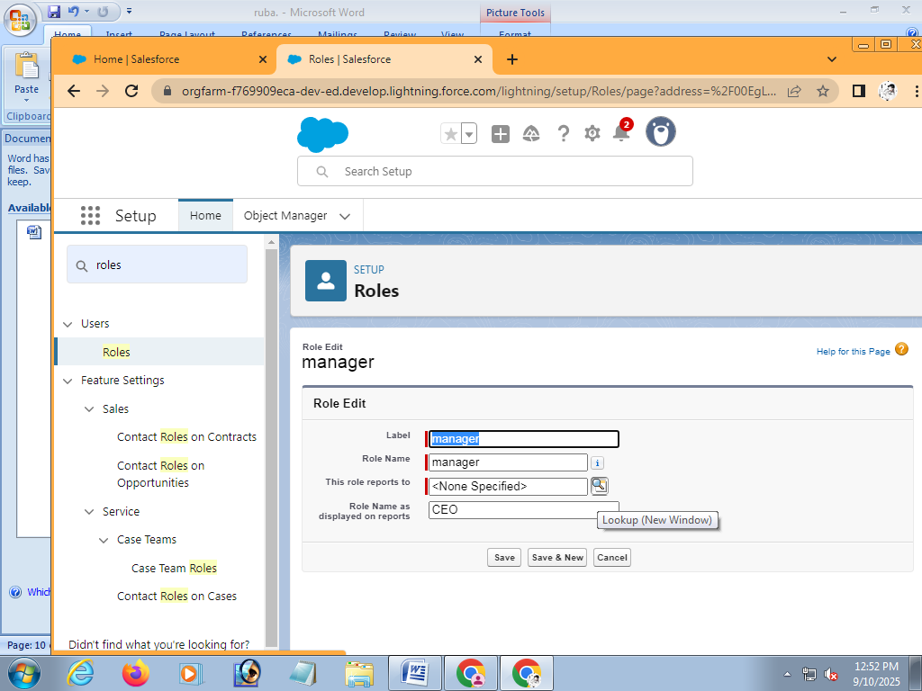

Go to setup>>type users in quick find box>>select users>>click New users.

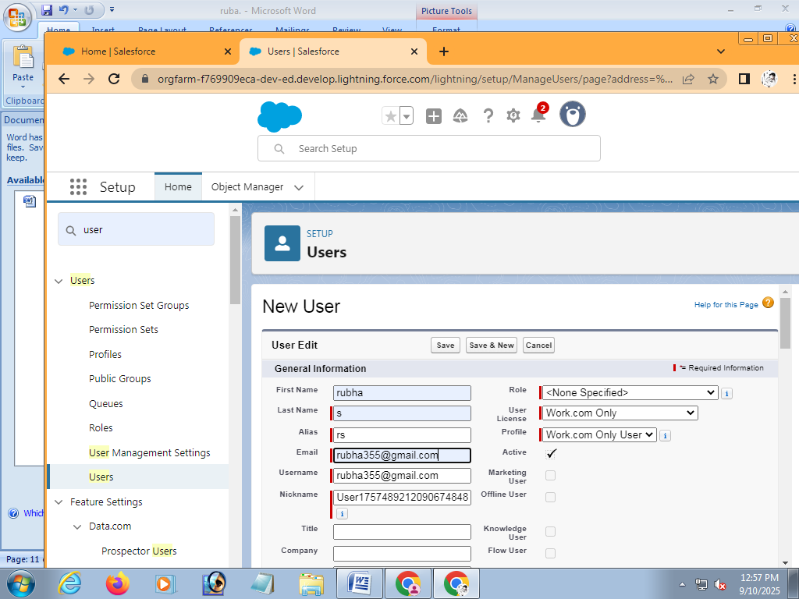

Go to setup>> type users in quick find box>>select public new.

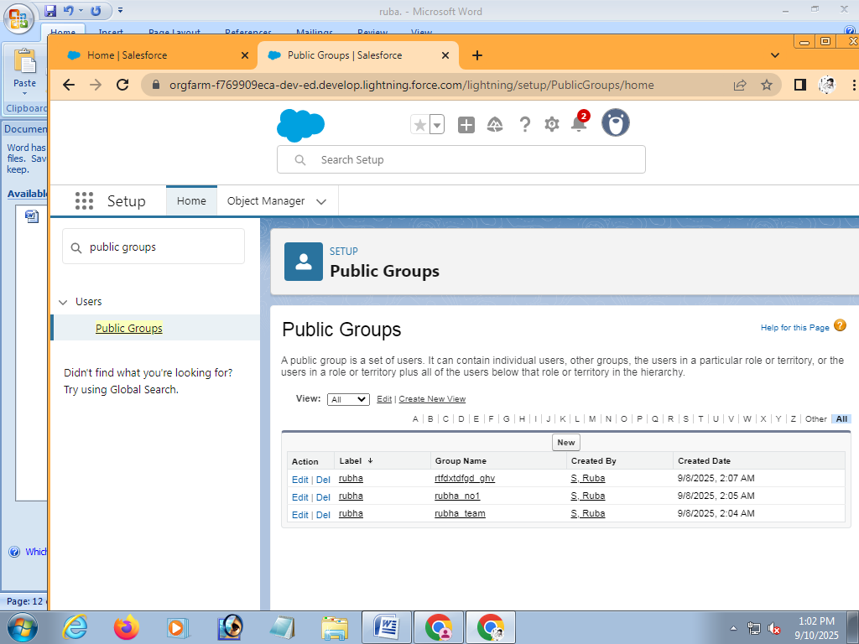

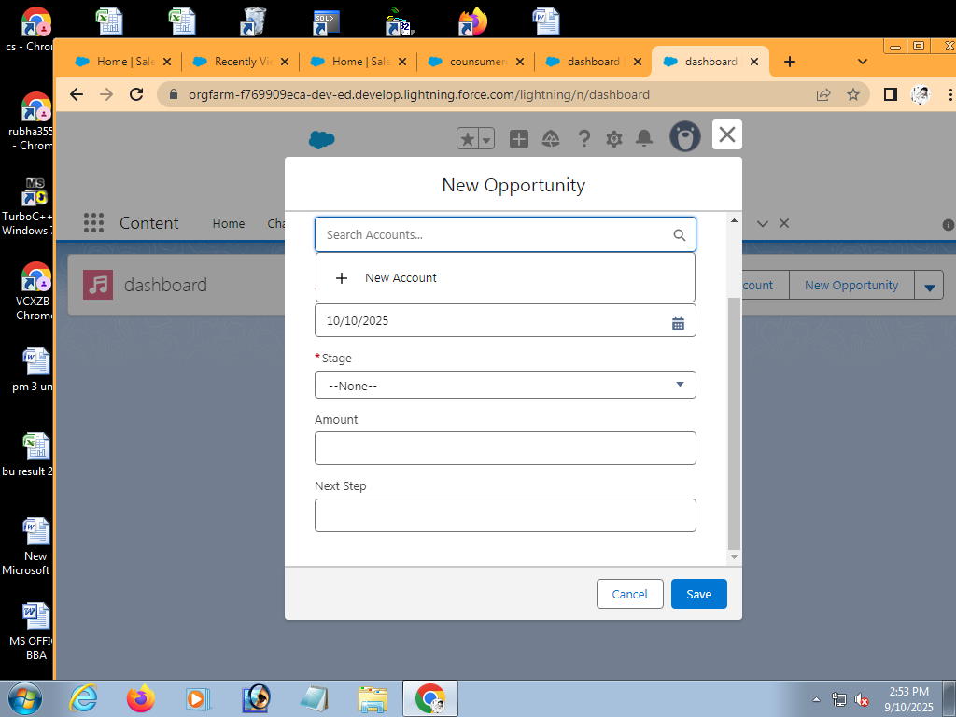

# Conclusion:

# The Garage Management system plays a crucial role in streamlining and automating day-to-day operations of Garage. It Enhamnces efficiency, reduces manual errors and improves customer satisfaction by offering timely Serice and better vehicle tracking . The system also help in managing inventory,biliing ,and reporting effectiving,leading to better resource utilization and prof itability. Overall,this solution supports the growth of the business by ensuring smooth workflow, accurate data management, and improved decision –making.

## APPENDIX:

# Appendix :Screenshorts

# *Login Page

# *Dashboard

# *Vehicle Entry Form

# *Reports

# *Billing/invoice page

# Database Details:

# Customer table

# Vehicle table

# Appointment Table

# Inventory table

# Billing table